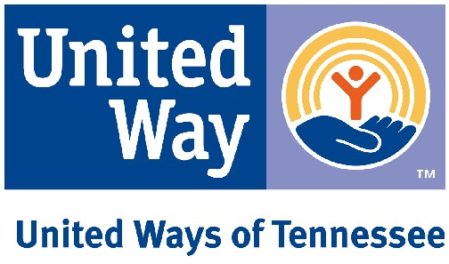

2024 DRAFT PUBLIC POLICY AGENDA
Tier 1 (Top priorities)

STATE
- Increase access to 211 and Tennessee Benefit Kitchen
- Increase access to internet and broadband in underserved communities
- Tax protections for charitable giving
Education | Financial Stability | Health
- Afterschool/OST and childcare access and quality, including use of available funding sources and credit recovery  - Increase preschool funding, access and quality  - Increase health, psychosocial, and mental health services in schools and out-of-school-time programming  - Expand use of the free care rule reversal beyond behavioral health services to cover all health services  - Provide trauma-informed and sensitive environments in school and afterschool/OST programs  - TN-CAPS and Learning Blade  - Enhance opportunities and take advantage of all possible sources of federal funding for education | - UWTN ALICE report components and findings  - Access to financial assistance for housing, utilities, healthy food and other basic needs  - TANF/Families First  - TN opportunity pilot initiative  - Tax relief policies that benefit low income and other vulnerable populations  - Justice, bail practices, court fees, incarceration, and returning citizens | - Preservation and expansion of access to healthcare coverage  - Preservation and expansion of ACES resources  - Preservation and expansion of home visitation  - Prevention and treatment of substance abuse, suicide prevention, domestic violence, and access to behavioral health services  - Implement multi-year continuous eligibility for all children on TennCare or Cover Kids until age 5  - Universal school meals

FEDERAL
Education | Financial Stability | Health
- Increase access to 211
- Increase access to internet and broadband
- Tax protections for charitable giving
- Afterschool and childcare (access and quality) | - Fair housing and tenant protections  - EITC/VITA  - SNAP | - Preservation and expansion of access to healthcare coverage  - Prevention and treatment of substance abuse, suicide prevention, domestic violence, and access to behavioral health services

Tier 2:
Monitoring, building groundwork for action, and/or signing-on as issues arise, but not taking a leadership role

STATE
Education | Financial Stability | Health
- Funding for communities in schools  - Funding for community schools | - Medical debt assistance and education  - Consumer education on strategies addressing financial hardships  - SNAP | - Health and social service infrastructure, including telehealth*  - Coordinated School Health  - Vaping/tobacco products (reducing access for youth)

FEDERAL
Education | Financial Stability | Health
- Early learning  - Funding for communities in schools | - Workforce development/WIOA | - Health and social service infrastructure*

*Mental health services, substance abuse prevention and treatment, senior services, intellectual disabilities, transportation for health and human services, long-term care, and social workers in schools and other settings.

